Variables
BMI
Variables are like labelled boxes that have a label (name of the variable) so that we know what is stored inside (value of the variable). Variables store a value & the value can change.
Let's do some body weight math - calculate Body Mass Index (BMI)!
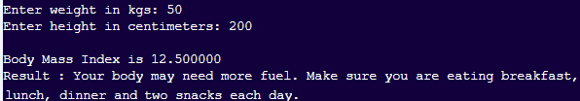
Get Ready
- Get project: Click on “Code” and then click save
Add Your Code
- Main block: Calculate and print BMI. If BMI is low, less than 18.5, print message ‘purple’
height = h/100;
bmi=weight/(height*height);
printf("\nBody Mass Index is %f\n",bmi);
if (bmi<18.5)
Here's our IF condition to decide!
printf("Result : %s\n\n", purple);
Try It Out!
- Click on Save. Click on Run.
- Remember! return 0 is used at the end of main block to indicate program has completed successfully.
Challenge!
Check for normal BMI
If BMI greater than 18.5 and less than 25, print message ‘green’
Hint:
else if (bmi>=18.5 && bmi<25)
printf("Result : %s\n\n", green);
High BMI
If BMI greater than 25, print the message ‘yellow’

Clean Inputs
If BMI is less than or equal to 0, print “Recheck inputs and try again”
FizzBuzz – New Project
Print numbers 1 to 50. For each number, if divisible by 3 print “Fizz”, if divisible by 5 print “Buzz” and if divisible by 15 print “FizzBuzz”
Test Yourself
What will be printed when this code is run?
if (4 < 5)
printf("A ");
else
printf("B ");
A
A B
B
B A
Fun Fact!
In printf() and scanf(), %d indicates variable must be an integer.

